A

Mini Project

On

**Deep Learning Application Medical Image Analysis**

**Brain Tumor**

BACHELOR OF TECHNOLOGY

In

COMPUTER SCIENCE AND ENGINEERING

By

VENKANNAGARI NIRANJAN REDDY (197R1A05H7)

CHALLARAM SHARATH REDDY (197R1A05D2)

BANOTHU SRINIVAS (197R1A05D0)

Under the Guidance of

B.P.DEEPAK KUMAR

(Associate Professor)



DEPARTMENT OF COMPUTER SCIENCE AND ENGINEERING

CMR TECHNICAL CAMPUS

## UGC AUTONOMOUS

## (Accredited by NAAC, NBA, Permanently Affiliated to JNTUH, Approved by AICTE, New Delhi) Recognized Under Section 2(f) & 12(B) of the UGCAct.1956, Kandlakoya (V), Medchal Road, Hyderabad-501401. 2019-2023)

**ABSTRACT:**

The tremendous success of machine learning algorithms at image recognition tasks in recent years intersects with a time of dramatically increased use of electronic medical records and diagnostic imaging. This review introduces the machine learning algorithms as applied to medical image analysis, focusing on convolutional neural networks, and emphasizing clinical vsigni_can’t hierarchal relationships within the data can be discovered algorithmically without laborious hand-crafting of features. We cover key research areas and applications of medical image classi_cation, localization, detection, segmentation, and registration. We conclude by discussing research obstacles, emerging trends, and possible future directions.

**INDEX TERMS** Convolutional neural networks, medical image analysis, machine learning, deep learning.

**INTRODUCTION:**

Machine learning algorithms have the potential to be invested deeply in all _elds of medicine, from drug discovery to clinical decision making, signi_cantly altering the way medicine is practiced. The success of machine learning algorithms at computer vision tasks in recent years comes at an opportune time when medical records are increasingly digitalized. The use of electronic health records (EHR) quadrupled from 11.8% to 39.6% amongst of_ce-based physicians in the US from 2007 to 2012 [1]. Medical images are an integral part of a patient's EHR and are currently analyzed by human radiologists, who are limited by speed, fatigue, and experience. It takes years and great _nancial cost to train a quali_ed radiologist, and some health-care systems outsource radiology reporting to lower-cost countries such as India via tele-radiology. A delayed or erroneous diagnosis causes harm to the patient. Therefore, it is ideal for medical image analysis to be carried out by an automated, accurate and ef_cient machine learning algorithm.

**EXISTING SYSTEM:**

There is a myriad of imaging modalities, and the frequency of their use is increasing. Smith-Bindman *et al.* [2] looked at imaging use from 1996 to 2010 across six large integrated healthcare systems in the United States, involving 30.9 million imaging examinations. The authors found that over the study period, CT, MRI and PET usage increased 7.8%, 10% and 57% respectively.

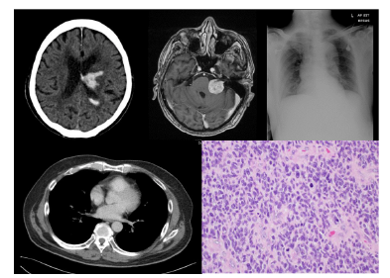

The symbolic AI paradigm of the 1970s led to the development of rule-based, expert systems. One early implementation in medicine was the MYCIN system by Shortliffe [3], which suggested different regimes of antibiotic therapies for patients. Parallel to these developments, AI algorithms moved from heuristics-based techniques to manual, handcrafted feature extraction techniques. and then to supervised learning techniques. Unsupervised machine learning methods

are also being researched, but the majority of the algorithms from 2015-2017 in the published literature have employed supervised learning methods,

**PROPOSED SYSTEM:**

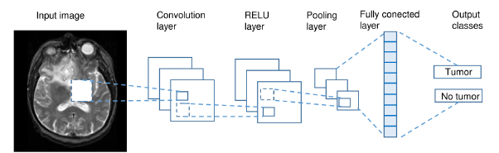

Currently, CNNs are the most researched machine learning algorithms in medical image analysis [4]. The reason for this is that CNNs preserve spatial relationships when _ltering input images. As mentioned, spatial relationships are of crucial importance in radiology, for example, in how the edge of a bone joins with muscle, or where normal lung tissue interfaces with cancerous tissue. As shown in Fig. 2., a CNN takes an input image of raw pixels, and transforms it via Convolutional Layers, Recti_ed Linear Unit (RELU) Layers and Pooling Layers. This feeds into a _nal Fully Connected Layer which assigns class scores or probabilities, thus classifying the input into the class with the highest probability.

Detection, sometimes known as Computer-Aided Detection (CADe) is a keen area of study as missing a lesion on a scan can have drastic consequences for both the patient and the clinician. The task for the Kaggle Data Science Bowl of 2017 [64] involved the detection of cancerous lung nodules on CT lung scans. Approximately 2000 CT scans were released for the competition and the winner Fangzhou [65] achieved a logarithmic loss score of 0.399. Their solution used a 3-D CNN inspired by U-Net architecture [19] to isolate local patches _rst for nodule detection. Then this output was fed into a second stage consisting of 2 fully connected layers for classi_cation of cancer probability. Shin *et al.* [24] evaluated _ve well-known CNN architectures in detecting thoracoabdominal lymph nodes and Interstitial lung disease on CT scans. Detecting lymph nodes is important as they can be a marker of infection or cancer. They achieved a mediastinal lymph node detection AUC score of 0.95 with a sensitivity of 85% using GoogLeNet, which was state of the art. They also documented the bene_ts of transfer learning, and the use of deep learning architectures of up to 22 layers, as opposed to fewer layers which was the norm in medical image analysis. Overfeat was a CNN pre-trained on natural images that won the ILSVRC 2013 localization task [66]. Ciompi *et al.* [67] applied Overfeat to 2-dimensional slices of CT lung scans oriented in the coronal, axial and sagittal planes, to predict

the presence of nodules within and around lung _ssures. They combined this approach with simple SVM and RF binary classi_ers, as well as a Bag of Frequencies [68], a novel 3-dimensional descriptor of their own invention.

**NOVALITY:**

**SOFTWARE REQUIREMENTS:**

OS : Windows

Python IDE : python 2.7.x and above

Pycharm IDE,

Anaconda 3.5

Setup tools and pip to be installed for 3.6.x and above

**HARDWARE REQUIREMENTS:**

RAM : 4GB and Higher

Processor : Intel i3 and above

Hard Disk : 500GB: Minimum